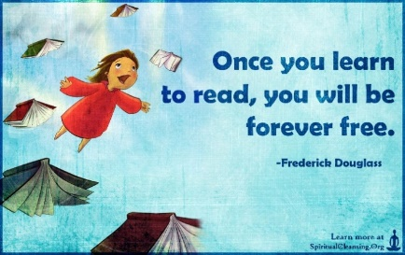
Culverhill School
Reading
Our Vision for Reading
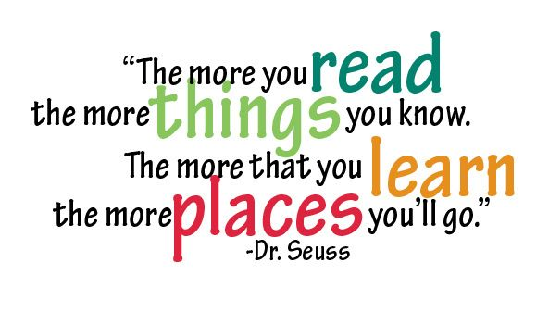

Culverhill School is a Special School for children with a wide range of complex and co-existing learning difficulties aged 7 - 16. Every child has an EHCP and we promote an ethos and culture that provides every child with a learning experience to develop their independence, skills and knowledge. Our aim is to enable our children to make a positive and valuable contribution to their own lives, the lives of their communities and society as a whole.
At Culverhill School we believe that reading is the gateway to our pupils’ empowerment, lifelong learning, enjoyment and achievement. We therefore place a high value on reading as a priority for all children and our staff are dedicated to promoting reading for all pupils. We recognise that, prior to joining us, our pupil join Culverhill with a range of different reading experiences and we work hard to encourage, support and engage all pupils with a love of reading.
As well as the mechanics of reading (decoding, phonic awareness), it is important that children are exposed to a love of reading and this is instilled at an early age by the adults around them: their parents, families and school staff. If this is encouraged at an early age, children will develop their own ability to fulfil a life-long love of reading and therefore learning. Our reading vision at Culverhill fosters this love, and opportunities for children to be read to and to read to others are embedded in our curriculum.
We also recognise that our children learn to read in different ways at different stages of their development. For our pupils who are at the pre-phonics stage, we will employ a bespoke multi-sensory approach using input from the SALT team and other professionals, delivered by our highly skilled staff. Our professional experience at Culverhill School tells us that many of our children who have a range of complex needs, fit with this cognitive and developmental profile. Therefore we have identified that these children primarily need a combination of learning word recognition and individual letter phonics before they are exposed to more complex phonological components such as blending and segmenting, digraphs and trigraphs. We will also be adopting the ‘See and Learn’ structured programme to support the development of early reading with children who require this approach as their initial pathway into learning to read.

